WEEK 4
Aim
To write a Java program that checks whether the two halves of a given string contain an equal number of vowels and returns true if they are alike, otherwise returns false.
Algorithm
- Start
- Read the input string s.
- Find the length n of the string.
- Initialize an integer variable count to 0.
- Traverse the string from index 0 to (n / 2) − 1:
  - If the character in the first half (s.charAt(i)) is a vowel, increment count.
  - If the character in the second half (s.charAt(i + n / 2)) is a vowel, decrement count.
- After completing the loop:
  - If count equals 0, both halves have the same number of vowels.
- Return true if count == 0, otherwise return false.
- Stop

import java.util.Set;
class Solution {
public boolean halvesAreAlike(String s) {
int n = s.length();
int count = 0;
for (int i = 0; i < n / 2; i++) {
if (isVowel(s.charAt(i))) {
count++;
}
if (isVowel(s.charAt(i + n / 2))) {
count--;
}
}

return count == 0;
}
private boolean isVowel(char c) {
c = Character.toLowerCase(c);
return c == 'a' || c == 'e' || c == 'i' || c == 'o' || c == 'u';
}
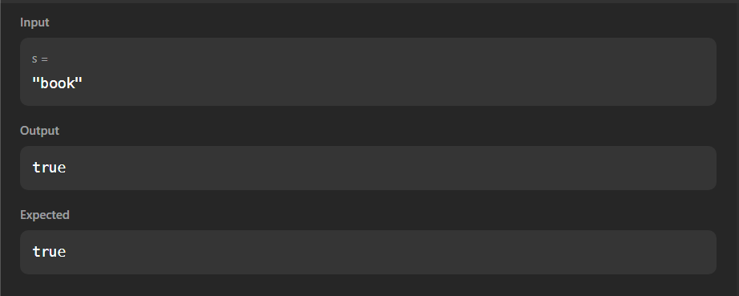
}
Aim
To write a Java program that checks whether a given string is a Lapindrome for multiple test cases and prints “YES” if it is a lapindrome, otherwise prints “NO”.
Algorithm
- Start
- Create a Scanner object to read input.
- Read an integer t representing the number of test cases.
- Repeat the following steps t times:
  - Read the input string s.
  - Find the length n of the string.
  - Create an integer array freq[26] to store character frequencies.
  - Traverse the first half of the string (from index 0 to n/2 - 1)
    - Increment the frequency of each character in the array.
  - Determine the starting index of the second half:
    - If n is even → start from n/2
    - If n is odd → start from n/2 + 1
  - Traverse the second half of the string
    - Decrement the frequency of each character in the array.
  - Check the frequency array:
    - If all values are 0, the string is a lapindrome → print “YES”
    - Otherwise → print “NO”
- Stop

import java.util.*;
import java.lang.*;
import java.io.*;
class Codechef
{
public static void main (String[] args) throws java.lang.Exception
{
Scanner sc = new Scanner(System.in);
if (sc.hasNextInt()) {
int t = sc.nextInt(); // Number of test cases
while (t-- > 0) {
String s = sc.next();
if (isLapindrome(s)) {
System.out.println("YES");
} else {
System.out.println("NO");
}
}
}
}
public static boolean isLapindrome(String s) {
int n = s.length();
int[] freq = new int[26]; // One slot for each letter 'a'-'z'

for (int i = 0; i < n / 2; i++) {
freq[s.charAt(i) - 'a']++;
}
int startSecondHalf = (n % 2 == 0) ? (n / 2) : (n / 2 + 1);
for (int i = startSecondHalf; i < n; i++) {
freq[s.charAt(i) - 'a']--;
}
for (int count : freq) {
if (count != 0) return false;
}
return true;
}



